Name:Mrs.Rupali N Hosmani.

Course:Executive Post Graduate Certification in Cloud Computing

Contact No. 7720003531

**Assignment: EC2 AND EFS**

**Tasks To Be Performed**: 1. Create an EFS and connect it to 3 different EC2 instances. Make sure that all instances have different operating systems. For instance, Ubuntu, Red Hat Linux and Amazon Linux 2

**Steps :**

1. Create your Amazon EFS file system
2. Launch three EC2 instances with Ubuntu, RedHat Llinux and Amazon Linux2 operating system.
3. Test the file system by connecting with 3 different EC2 instances.

1.Sign in to AWS Management Console & select EFS service:

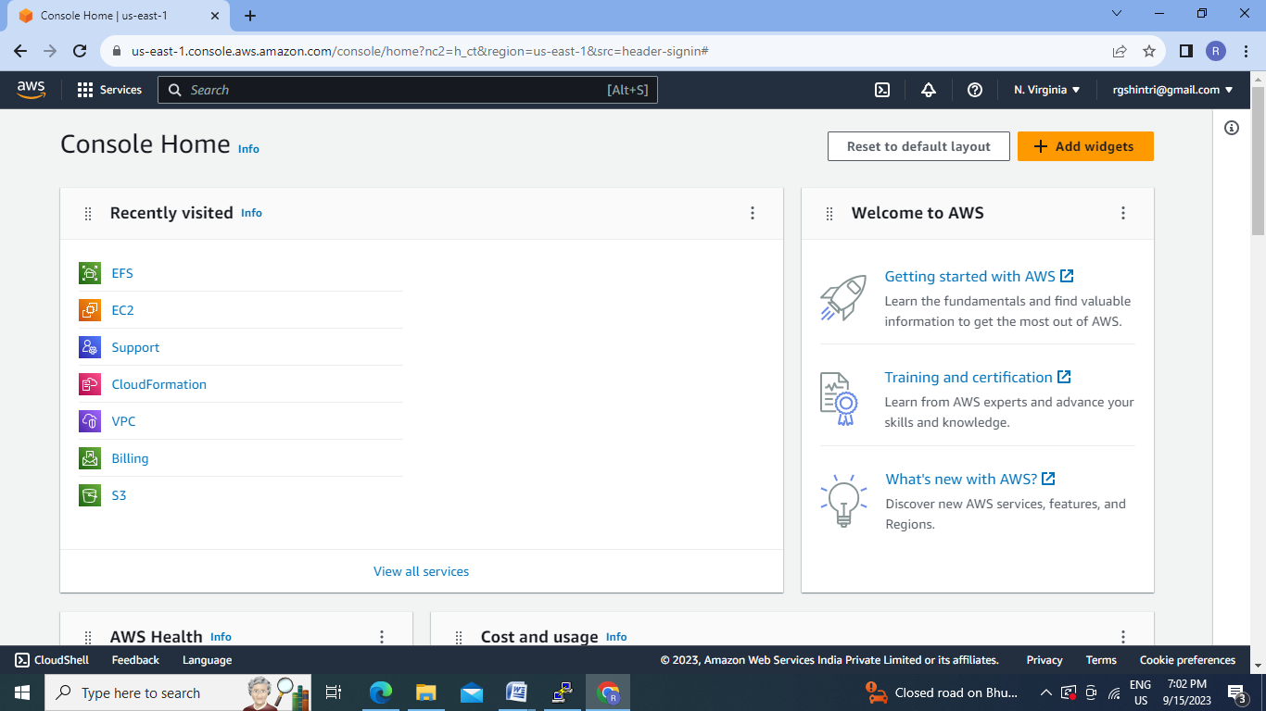

2. Create File System:

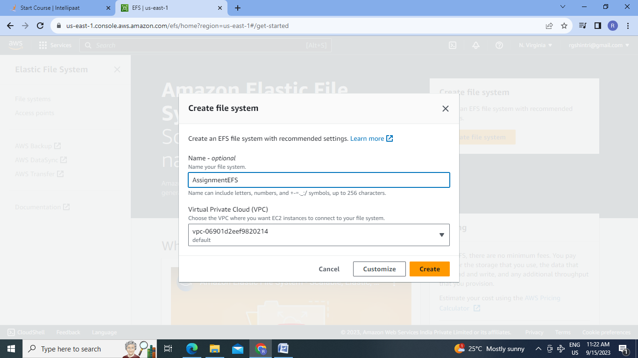

3.EFS created:

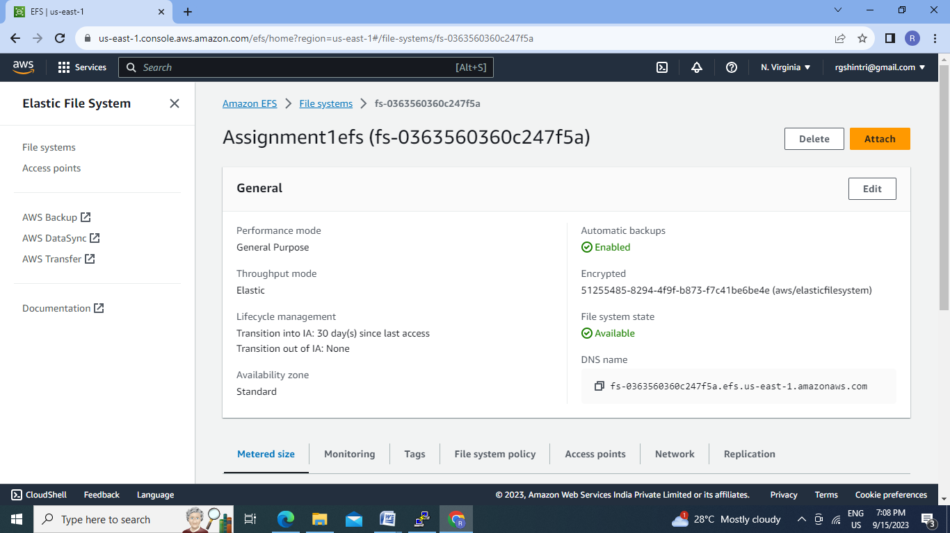

4.Select EC2 service :

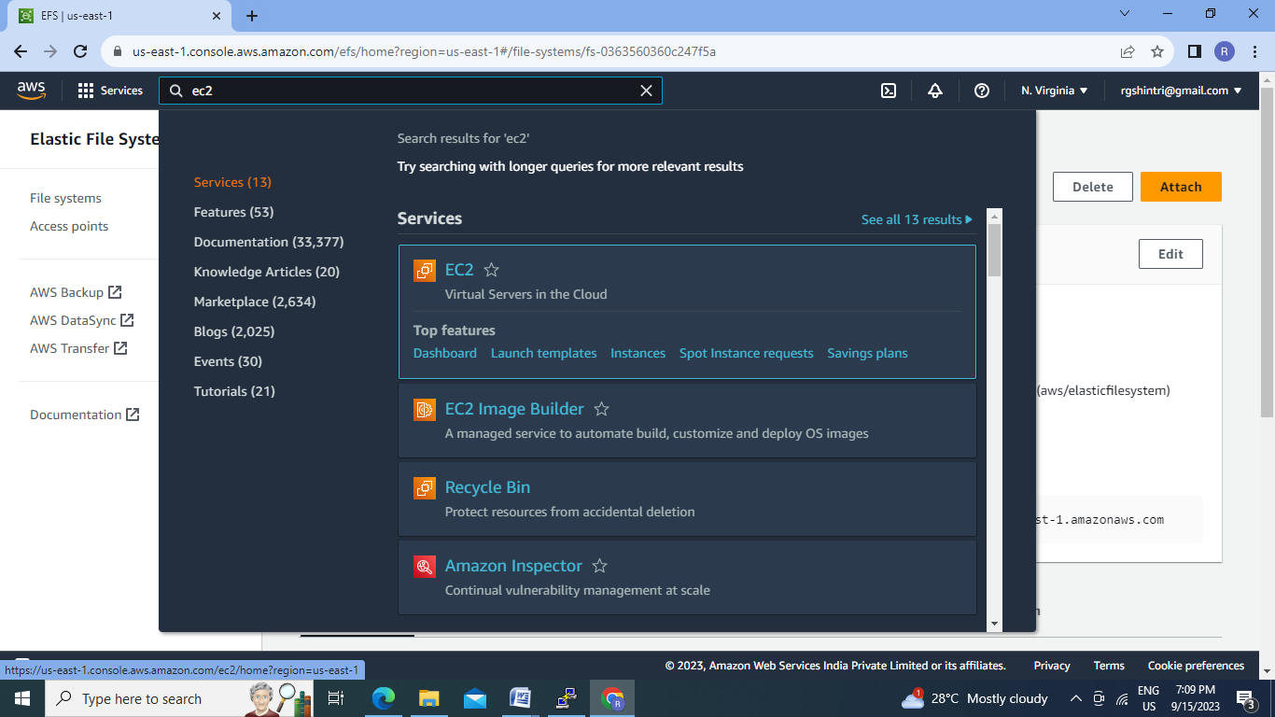

5.Launch Ubuntu EC2 instance :

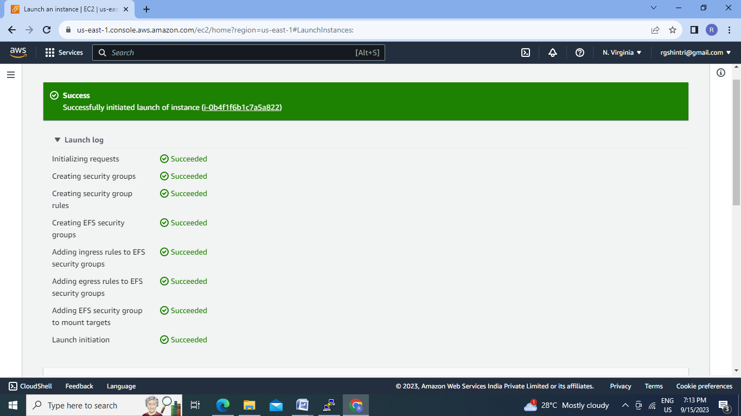

6.Launch Amazon Linux 2 EC2:

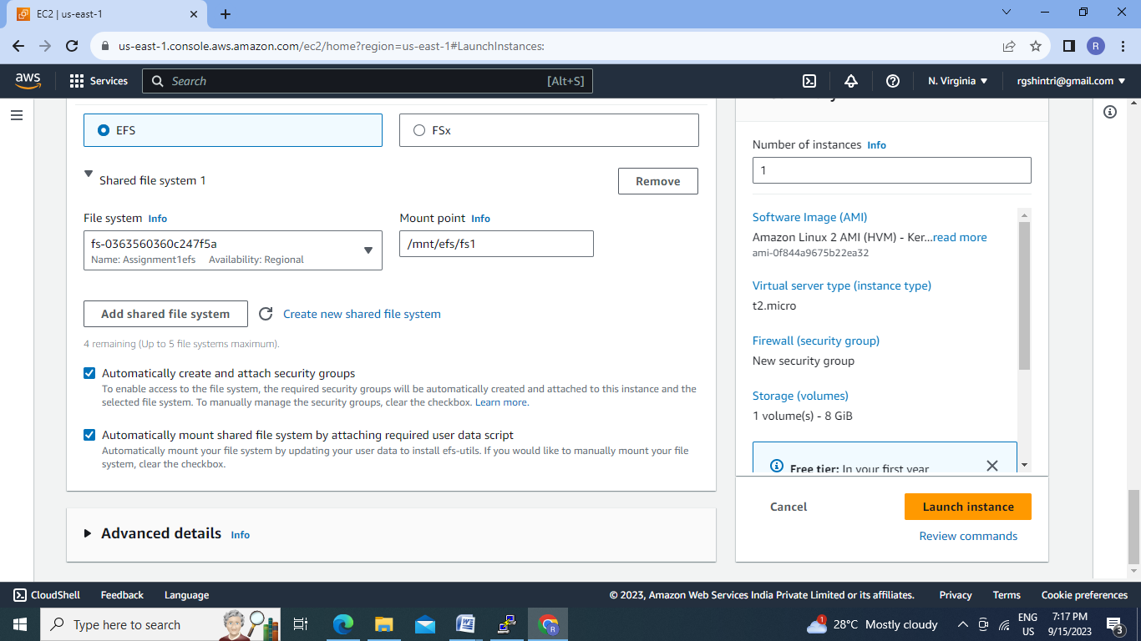

7.Launch EC2 instance with RedHat Linux operating system:

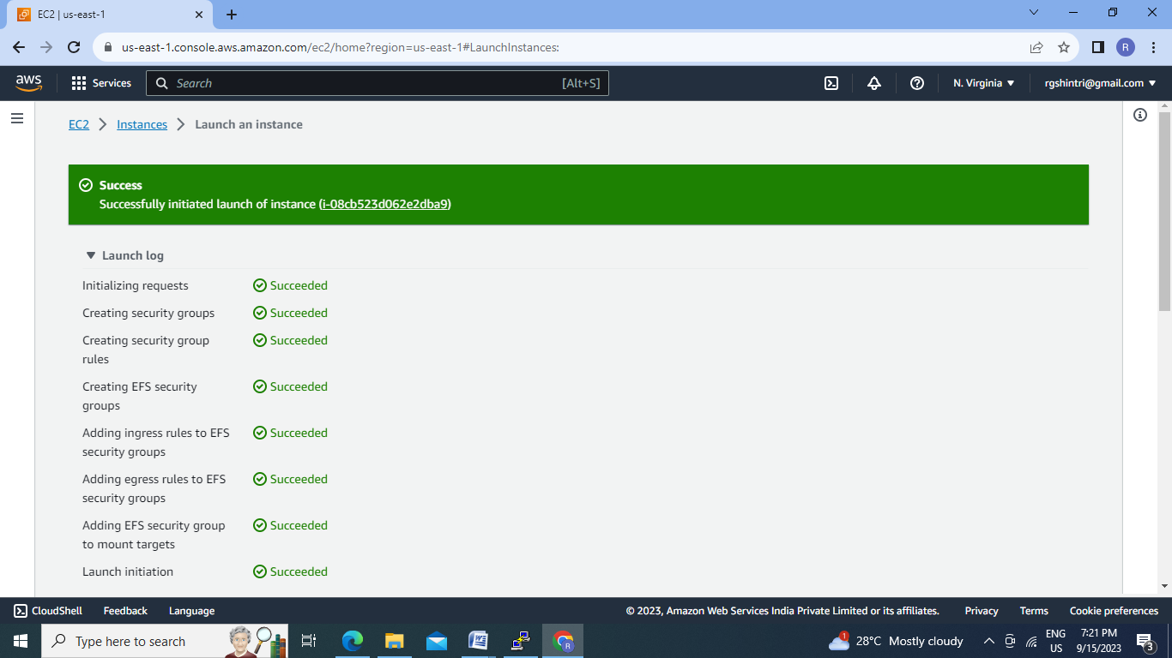

8.Connect Ubuntu EC2 instance & check for EFS:

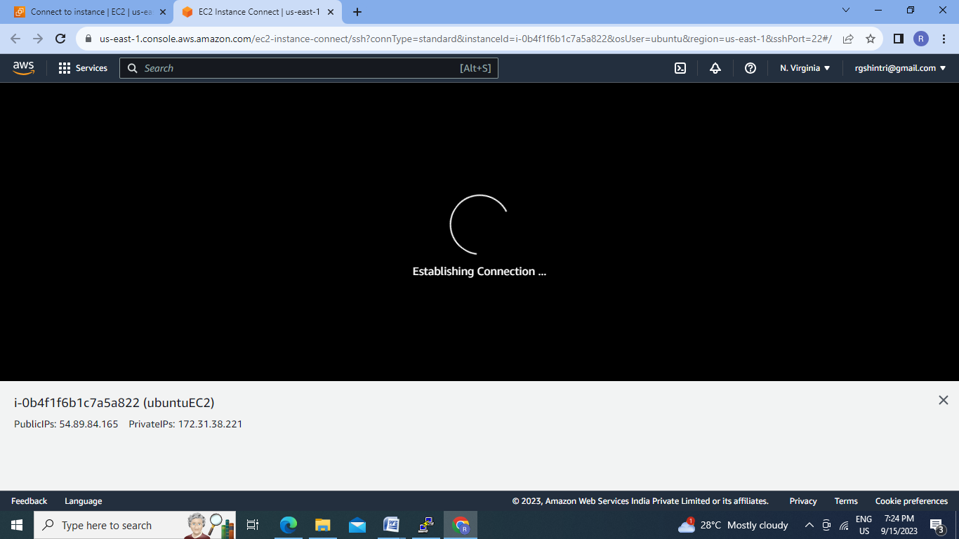

10.Connection of UbuntuEC2 instance:

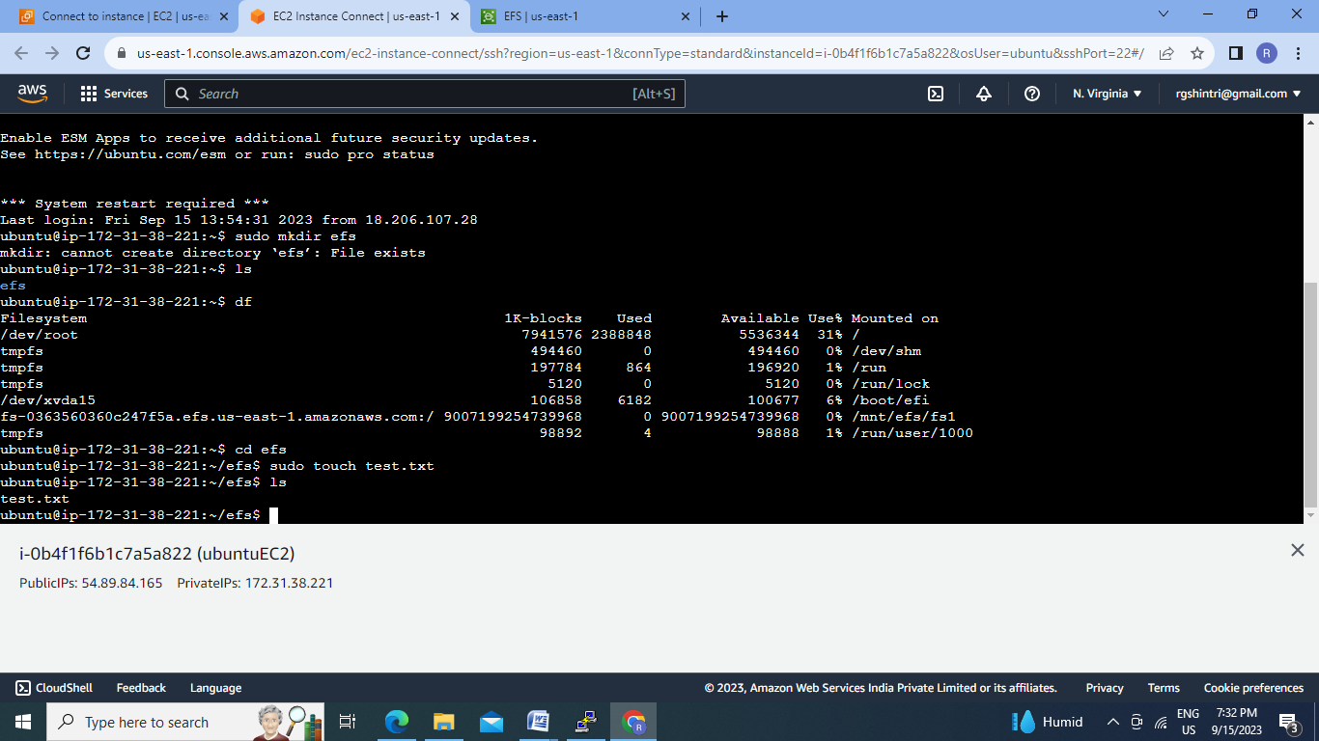

11.Connect Amazon Linux2 EC2 instance :

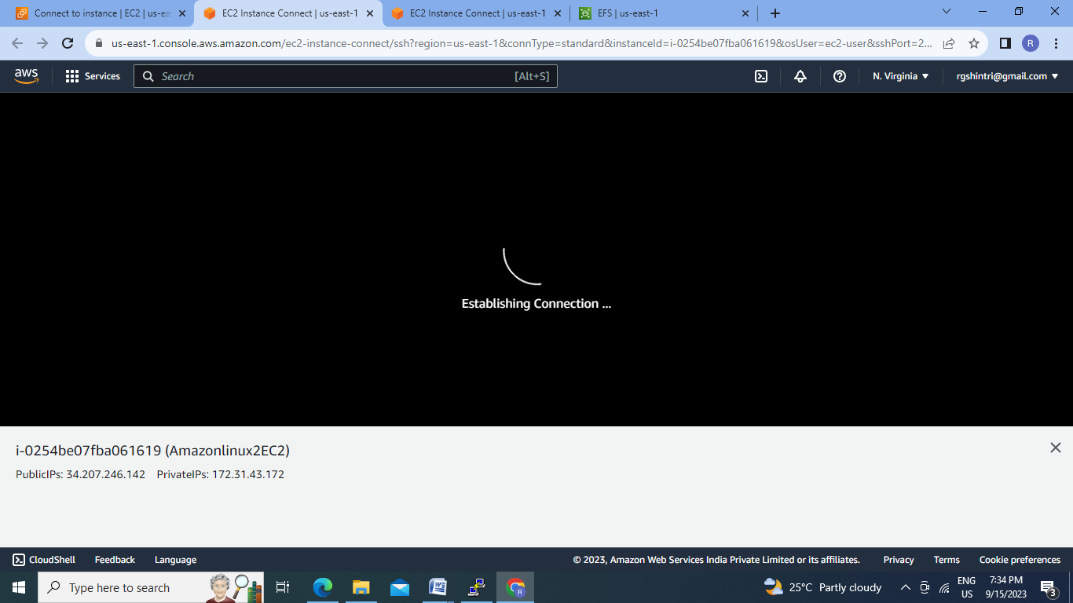

12.Connect Amazon linux EC2 instance and check for EFS:

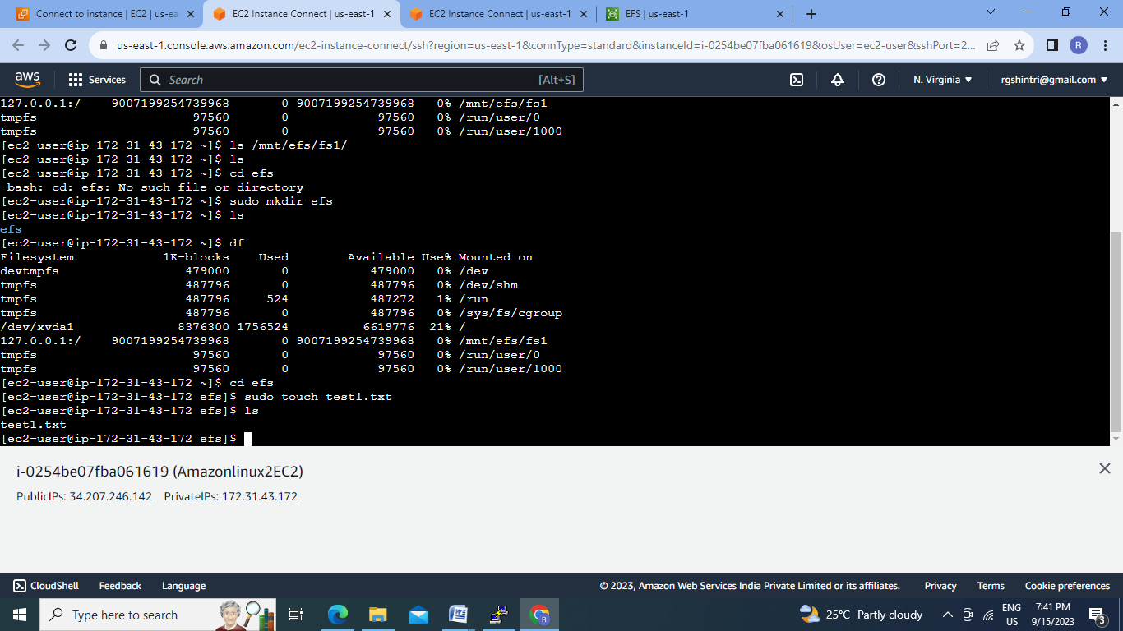

13.Connect redHatEC2 instance and check for EFS:

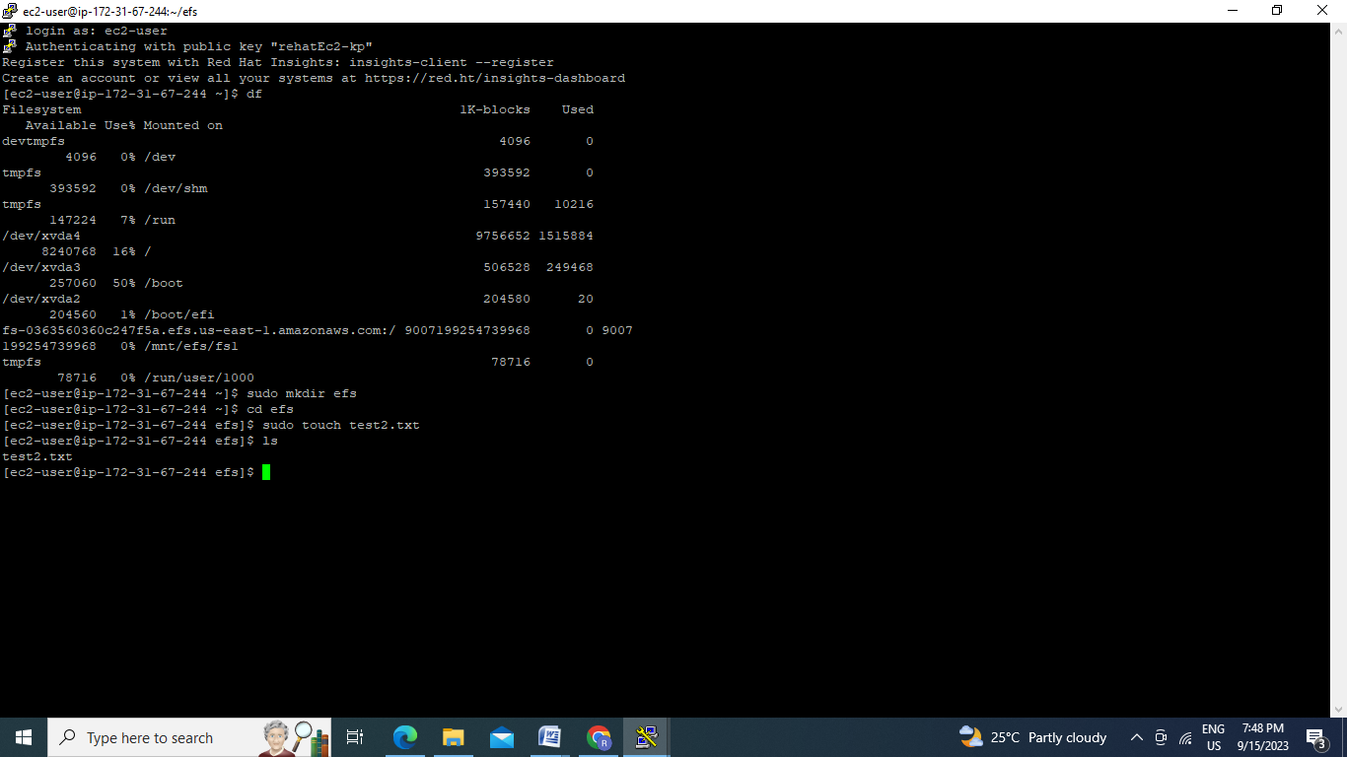

Conclusion:- Multiple instances can be attached to one EFS.